Boost Inductor Magnetic Design — Full Report
EDGE Core 0059392A2 (2-Stack) · 2-Channel Interleaved CCM PFC · Per-Phase Analysis
V_out = 390 Vdc · f_sw = 70 kHz · f_line = 60 Hz · N = 32 (AL-nominal) · validated EDGE 60µ material model · iGSE cycle-averaged losses

Step 1) Reference Operating Point and Design Targets

Step 1.1) Converter parameters
Parameter | Value
Output voltage V_out | 390 Vdc
Switching frequency f_sw | 70 kHz
Line frequency | 60 Hz
Topology | 2-channel interleaved CCM boost PFC
Input range | 90 – 264 Vac (two power corners: 90–132 / 180–264)
Target inductance Lφ (low line, full load) | 235 µH per phase

Step 1.2) Per-phase operating currents (converter Table A)
Iφ,avg@crest = I_pk,line / 2 Iφ,rms includes switching ripple
V_in (Vac) | V_in,pk (V) | I_pk,line (A) | Iφ,avg@crest (A) | Iφ,rms (A) | D@crest
90 | 127.3 | 28.30 | 14.1522 | 10.1196 | 0.6736
110 | 155.6 | 22.92 | 11.4590 | 8.2672 | 0.6011
120 | 169.7 | 20.79 | 10.3963 | 7.5413 | 0.5649
132 | 186.7 | 18.72 | 9.3589 | 6.8346 | 0.5213
180 | 254.6 | 29.64 | 14.8195 | 10.5932 | 0.3473
200 | 282.8 | 26.41 | 13.2075 | 9.4382 | 0.2748
220 | 311.1 | 24.00 | 11.9990 | 8.5561 | 0.2022
230 | 325.3 | 22.89 | 11.4436 | 8.1472 | 0.1660
264 | 373.4 | 20.46 | 10.2309 | 7.2397 | 0.0427
Note: the 180–264 V rows carry higher currents than 90–132 V — the two ranges are distinct power corners. No interpolation is performed between 132 and 180 Vac anywhere in this report.

Step 2) Methodology and Corrections Incorporated
This report supersedes the original 3-stack 0059894A2 calculation. Corrections identified and applied during design review:
# | Correction | Effect
1 | Window area does not stack: Wa is the bore (156 mm² small core / 355 mm² this core), not Σ per-core Wa | Original 3-stack winding was physically unwindable; drove core change
2 | Cross-section corrected (Ae = 153 mm²/core; original used wrong 231 mm² total) | Flux density and core loss corrected
3 | MLT is the winding length/turn 2·(w + S·HT)+build, not π·D_mean (ring path) | Copper length +~30% vs original
4 | Cycle-averaged time-domain core loss replaces crest-point value | Crest method erred +83% (90 V) to −97% (264 V)
5 | Validated EDGE 60µ coefficients replace circular k/n curve fit | Material-anchored loss and bias models
6 | True iGSE triangular-ripple correction F(D) applied | Core loss ~5% below sinusoidal-Steinmetz assumption
7 | Explicit HF-ripple copper term I_hf²·R_ac | Quantified (≈8 mW) instead of assumed
8 | SPG bias-loss adder NOT applied (powder core) | DC bias adds no core loss directly; bias acts via permeability roll-off only

Step 3) EDGE 60µ Material Model (Validated)

Step 3.1) Core-loss density
P_L [mW/cm³] = a · B_ac,pk[T]^b · f[kHz]^c
b = 2.106 c = 1.444 (EDGE-family exponents from catalog fit)
a_max = 86.7 (anchored to part datasheet: 525 mW/cm³ max @ 0.1 T, 100 kHz)
a_typ = 67.4 (triangulated from 150 mW/cm³ typ @ 0.1 T, 50 kHz via exponent c)
Validation: a_max·0.1^2.106·100^1.444 = 525.0 mW/cm³ ✓ (reproduces datasheet anchor)

Step 3.2) Permeability vs DC bias
%µi = 1 / (0.01 + 9.202×10⁻¹⁰ · H^3.044), H in Oe
Validation: H=130 Oe → 80.0% ✓ ; H=205 Oe → 50.0% ✓ (matches catalog spec points)

Step 3.3) iGSE triangular-ripple correction
F(D) = 2^c · [D^(1−c) + (1−D)^(1−c)] / [(2π)^(c−1) · ∫₀^2π|cosθ|^c dθ], ∫ = 3.5435
D | 0.347 (180 V crest) | 0.5 (ripple max) | 0.674 (90 V crest)
F(D) | 0.953 | 0.924 | 0.963
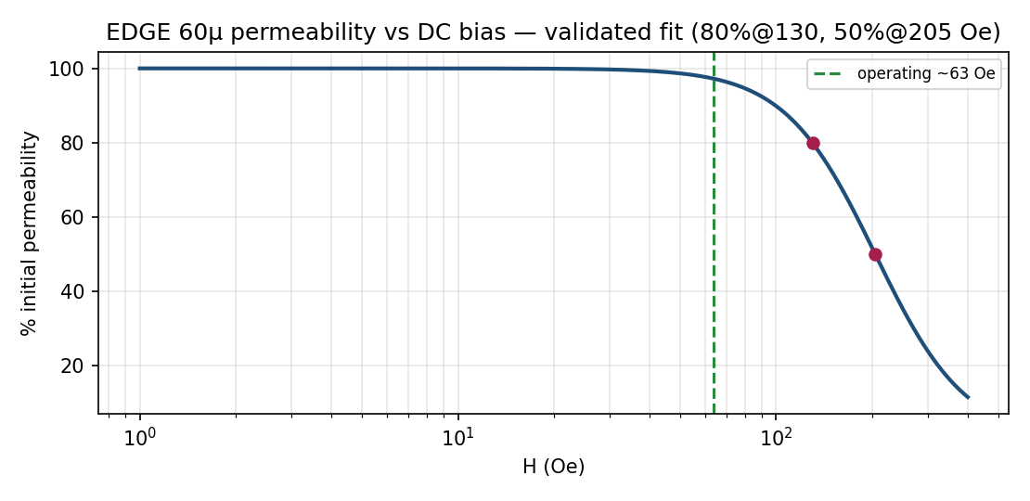
Figure 3.1 — EDGE 60µ permeability vs DC bias, validated fit with operating point.
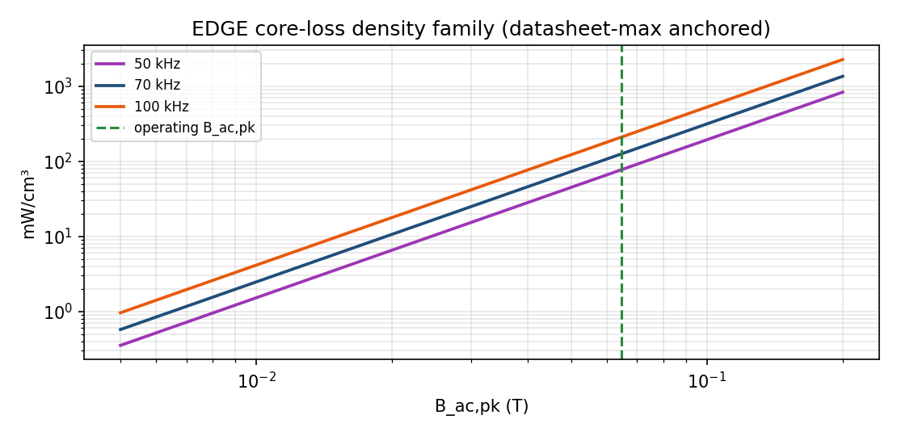
Figure 3.2 — EDGE core-loss density family at 50/70/100 kHz with operating flux marked.

Step 4) Selected Core and Stacking Parameters — 0059392A2 × 2
Quantity | Single core | 2-Stack | Stacks?
AL nominal (±8%) | 122 nH/T² | 244 nH/T² (224.5–263.5) | ×2
Cross-section Ae | 153 mm² | 306 mm² | ×2
Path length Le | 94 mm | 94 mm | unchanged
Window area Wa (bore) | 355 mm² | 355 mm² | unchanged
Volume Ve | 14.6 cm³ | 29.2 cm³ | ×2
Dimensions (coated) | OD 40.94 / ID 21.27 / HT 17.89 mm | stack height 35.78 mm | —
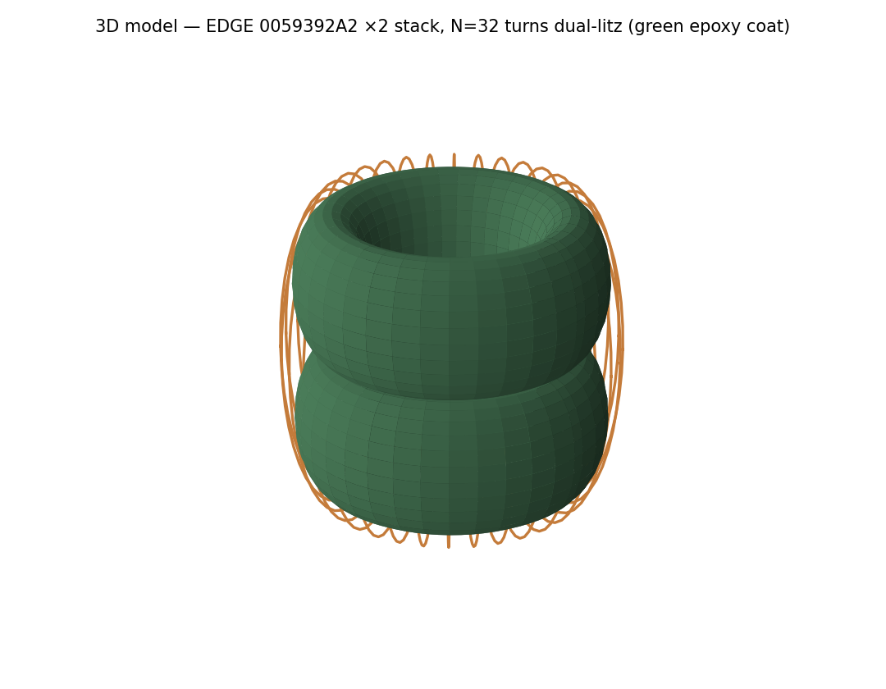
Figure 4.1 — 3D model of the 2-stack EDGE toroid with N=32 dual-litz winding (green epoxy coat per datasheet).

Step 5) Number of Turns — N = 32 (AL-Nominal Sizing)

Step 5.1) Governing equations
L₀ = AL,total · N²
H[Oe] = 0.4π · N · Iφ,avg@crest / Le[cm]
L_full = k(H) · L₀, k(H) from Step 3.2

Step 5.2) Worked example — 90 Vac full load
L₀,nom = 244 nH × 32² = 249.9 µH (min 229.9 / max 269.8 µH)
A·T = 32 × 14.1522 = 452.9 H = 0.4π·452.9/9.4 = 60.5 Oe
k = 0.9761 L_full = 0.9761 × 249.9 = 243.9 µH ≥ 235 µH ✓

Step 5.3) Inductance retention at full-load crest — all input voltages
V_in (Vac) | Iφ,avg@crest (A) | A·T | H (Oe) | k(H) | L_full min (µH) | L_full nom (µH) | L_full max (µH)
90 | 14.15 | 452.9 | 60.5 | 0.9761 | 224.4 | 243.9 | 263.4
110 | 11.46 | 366.7 | 49 | 0.9873 | 226.9 | 246.7 | 266.4
120 | 10.40 | 332.7 | 44.5 | 0.9905 | 227.7 | 247.5 | 267.3
132 | 9.36 | 299.5 | 40 | 0.9931 | 228.3 | 248.1 | 268
180 | 14.82 | 474.2 | 63.4 | 0.9726 | 223.6 | 243 | 262.5
200 | 13.21 | 422.6 | 56.5 | 0.9806 | 225.4 | 245 | 264.6
220 | 12.00 | 384 | 51.3 | 0.9854 | 226.5 | 246.2 | 265.9
230 | 11.44 | 366.2 | 49 | 0.9874 | 227 | 246.7 | 266.4
264 | 10.23 | 327.4 | 43.8 | 0.991 | 227.8 | 247.6 | 267.4
Tolerance note: sized on AL-nominal, the worst-bias AL−8% case gives ~224 µH (≈5% under target) — the accepted consequence of nominal-AL sizing. N=33 is the floor for 235 µH at AL-min. Bias retention stays ≥97% everywhere (EDGE 60µ knee is far away at 130/205 Oe).

Step 6) Inductance at Full Load vs Input Voltage
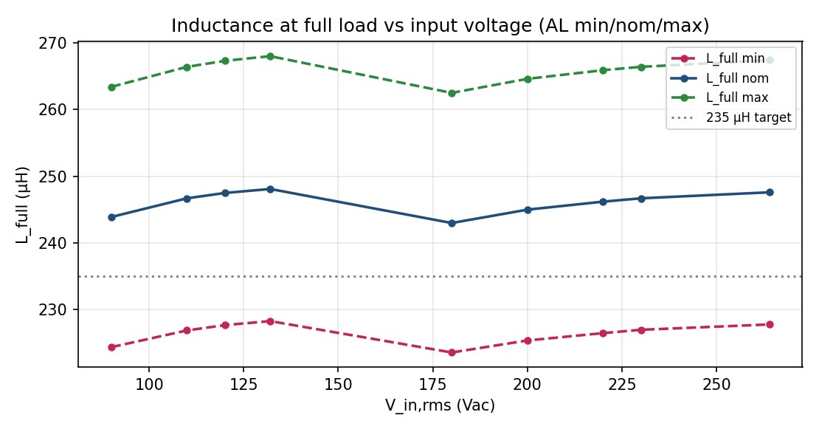
Figure 6.1 — L_full vs V_in for AL min/nominal/max with 235 µH target.

Step 7) Flux Density

Step 7.1) Governing equations and worked example (90 Vac crest)
ΔB_pp(t) = V_in(t)·D(t) / (N·Ae·f_sw) B_ac,pk(t) = ΔB_pp(t)/2
B_dc(t) = L(H(t))·iφ(t) / (N·Ae) B_max(t) = B_dc + B_ac,pk
ΔB_pp = 127.279 × 0.6736 / (32 × 306e-6 × 70000) = 0.1251 T → B_ac,pk = 0.0625 T

Step 7.2) Flux summary — all input voltages
V_in (Vac) | D@crest | B_ac,pk@crest (T) | B_dc peak (T) | B_max peak (T)
90 | 0.674 | 0.0625 | 0.352 | 0.415
110 | 0.601 | 0.0682 | 0.289 | 0.357
120 | 0.565 | 0.0699 | 0.263 | 0.333
132 | 0.521 | 0.0710 | 0.237 | 0.308
180 | 0.347 | 0.0645 | 0.368 | 0.432
200 | 0.275 | 0.0567 | 0.330 | 0.387
220 | 0.202 | 0.0459 | 0.302 | 0.348
230 | 0.166 | 0.0394 | 0.288 | 0.328
264 | 0.043 | 0.0116 | 0.259 | 0.270
Peak flux ≤0.43 T against EDGE saturation ≈1 T (>2.3× margin). B_ac,pk maximizes where V_in = V_out/2 = 195 V (D = 0.5), reached twice per half-cycle at high line.
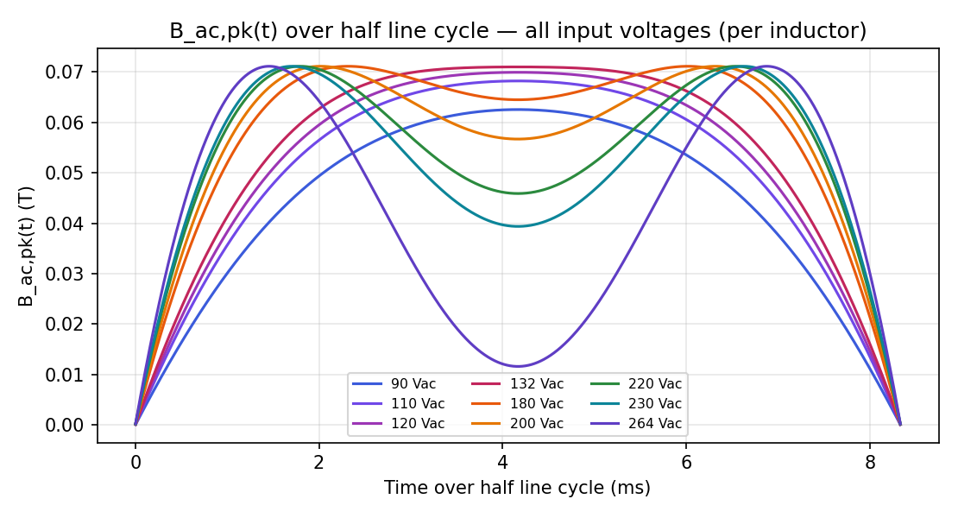
Figure 7.1 — B_ac,pk(t) over half line cycle, all input voltages (per inductor).
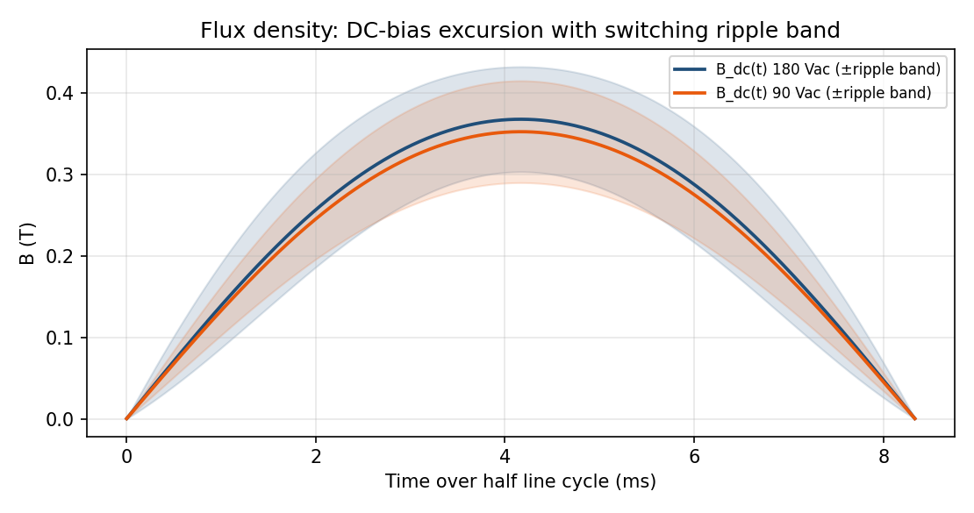
Figure 7.2 — DC-bias flux excursion with switching-ripple band (90 / 180 Vac).

Step 8) Magnetizing Field H(t)
iφ(t) = Iφ,pk·sin(θ) H(t)[Oe] = 0.4π·N·iφ(t)/Le[cm]
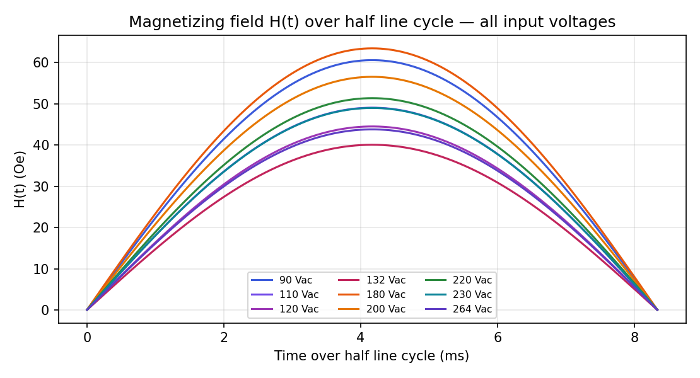
Figure 8.1 — H(t) over half line cycle, all input voltages. Peak 63.4 Oe (180 Vac) stays far below the 50% knee at 205 Oe.

Step 9) Winding Design and Window Fit

Step 9.1) Wire and copper path
Quantity | Value
Wire | 2 × TRW(F)(L)-0.1 litz (0.1 mm × 200) in parallel, 3.14 mm² Cu, bundle OD 2.23 mm
MLT (2-stack) = 2·(9.835 + 2×17.89) + 3.8 | 95 mm/turn
Copper length = 32 × MLT | 3.041 m
DCR @20 / 25 / 100 °C | 19.2 / 19.58 / 25.26 mΩ

Step 9.2) Window fit and layer screening
Metric | Value | Assessment
Bare-copper fill | 28.3 % | healthy
Insulated-bundle fill (2 × 2.23 mm/turn) | 70.4 % | full but windable
Geometric layer capacities (shrinking circumference) | 26 / 20 / 14 / 8 | 4 layers used (64 passes)
Remaining feed hole | ≈ 3.46 mm | shuttle-limited — confirm with winding house
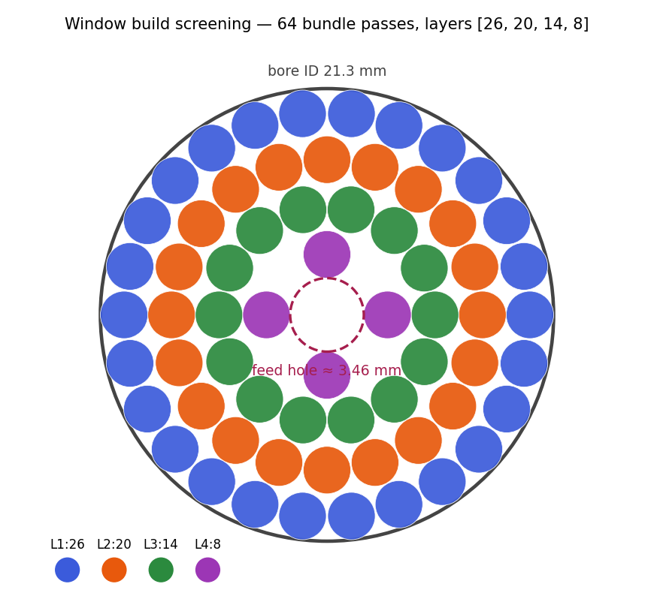
Figure 9.1 — Window build screening (first-order packing, not a geometric winding solver).

Step 10) Copper Loss
P_cu = Iφ,rms² · DCR(T) + I_hf,rms² · (R_ac − R_dc), R_ac/R_dc ≈ 1.15 (litz)
Skin depth @70 kHz = 0.249 mm vs strand Ø0.1 mm → per-strand skin factor 1.0005 (negligible)
V_in (Vac) | Iφ,rms (A) | I_hf,rms (A) | P_cu @25 °C (W) | P_cu @100 °C (W)
90 | 10.120 | 1.09 | 2.009 | 2.591
110 | 8.267 | 1.22 | 1.343 | 1.732
120 | 7.541 | 1.27 | 1.118 | 1.442
132 | 6.835 | 1.31 | 0.920 | 1.186
180 | 10.593 | 1.39 | 2.203 | 2.841
200 | 9.438 | 1.35 | 1.750 | 2.257
220 | 8.556 | 1.28 | 1.438 | 1.855
230 | 8.147 | 1.24 | 1.304 | 1.682
264 | 7.240 | 1.09 | 1.030 | 1.328

Step 11) Core Loss — Time-Domain iGSE, Cycle-Averaged

Step 11.1) Governing equations (one per line)
V_in(t) = V_pk·sin(2π·f_line·t), t ∈ [0, 1/(2·f_line)]
D(t) = 1 − V_in(t)/V_out
B_ac,pk(t) = V_in(t)·D(t) / (2·N·Ae·f_sw)
P_core(t) = a · B_ac,pk(t)^b · (f_sw/1000)^c · F(D(t)) · Ve / 1000 [W]
P_core,avg = (1/T_half) ∫ P_core(t) dt P_core,pk = max P_core(t)

Step 11.2) Core-loss metrics — all input voltages (max-anchored; typ in parallel column)
V_in (Vac) | P_core,avg typ (W) | P_core,avg max (W) | P_core,pk max (W) | t @pk (ms) | V_in @pk (V) | D @pk
90 | 1.533 | 1.973 | 3.282 | 4.17 | 127 | 0.674
110 | 1.882 | 2.421 | 3.831 | 4.17 | 156 | 0.601
120 | 2.027 | 2.608 | 4.005 | 4.17 | 170 | 0.565
132 | 2.169 | 2.792 | 4.115 | 4.17 | 187 | 0.521
180 | 2.364 | 3.041 | 4.128 | 2.31 | 195 | 0.500
200 | 2.268 | 2.918 | 4.128 | 6.31 | 195 | 0.500
220 | 2.087 | 2.686 | 4.128 | 1.80 | 195 | 0.500
230 | 1.973 | 2.538 | 4.128 | 1.71 | 195 | 0.500
264 | 1.540 | 1.981 | 4.128 | 1.46 | 195 | 0.500
At high line the peak occurs off-crest where V_in ≈ 195 V (D ≈ 0.5) — the double-hump signature. Using the crest value instead of the cycle average was the original report's largest core-loss error.
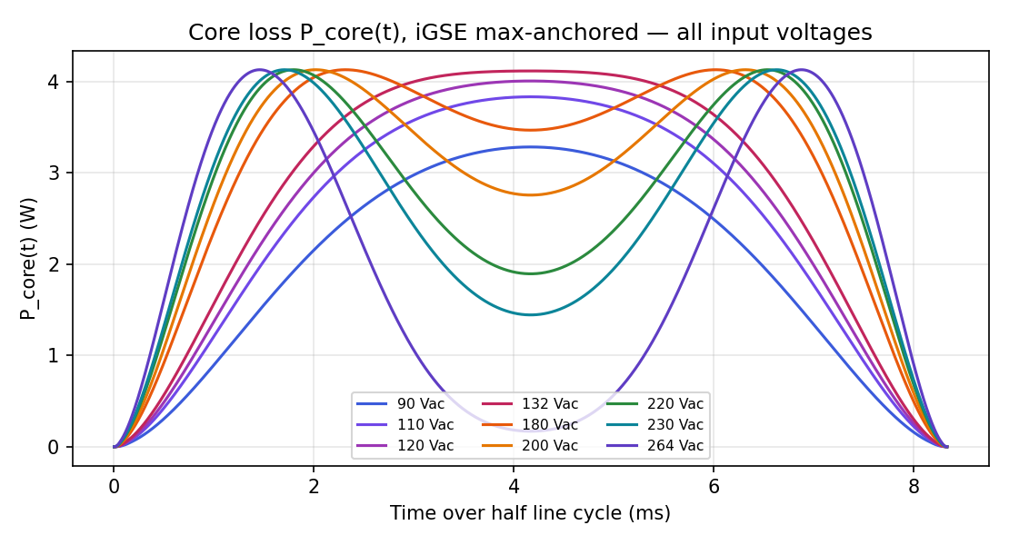
Figure 11.1 — P_core(t) (iGSE, max-anchored) over half line cycle, all input voltages.

Step 12) Inductor Loss vs Input Voltage (Per Phase)
V_in (Vac) | B_ac,pk@crest (T) | P_core typ (W) | P_core max (W) | P_cu 100°C (W) | P_total typ (W) | P_total max (W) | P_total max @25°C (W)
90 | 0.0625 | 1.53 | 1.97 | 2.59 | 4.12 | 4.56 | 3.98
110 | 0.0682 | 1.88 | 2.42 | 1.73 | 3.61 | 4.15 | 3.76
120 | 0.0699 | 2.03 | 2.61 | 1.44 | 3.47 | 4.05 | 3.73
132 | 0.0710 | 2.17 | 2.79 | 1.19 | 3.36 | 3.98 | 3.71
180 | 0.0645 | 2.36 | 3.04 | 2.84 | 5.21 | 5.88 | 5.25
200 | 0.0567 | 2.27 | 2.92 | 2.26 | 4.53 | 5.17 | 4.67
220 | 0.0459 | 2.09 | 2.69 | 1.85 | 3.94 | 4.54 | 4.12
230 | 0.0394 | 1.97 | 2.54 | 1.68 | 3.65 | 4.22 | 3.84
264 | 0.0116 | 1.54 | 1.98 | 1.33 | 2.87 | 3.31 | 3.01
Worst case = 180 Vac: P_total = 5.21 W (typ) / 5.88 W (max) per inductor — copper (2.84 W) and core (3.04 W) co-dominant.
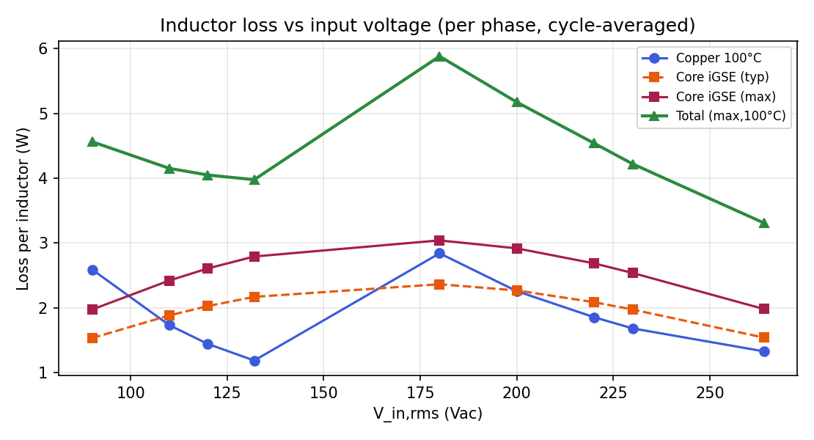
Figure 12.1 — Loss components vs input voltage (cycle-averaged, 100 °C copper).

Step 13) Total Loss Over the Half Line Cycle
P(t) = P_core(t) + P_cu(t), P_cu(t) = R_dc·iφ(t)² + R_ac·i_hf,rms(t)²
V_in (Vac) | P_total,avg max (W) | P_total,pk (W) | t @pk (ms)
90 | 4.564 | 8.402 | 4.17
110 | 4.153 | 7.219 | 4.17
120 | 4.050 | 6.809 | 4.17
132 | 3.978 | 6.403 | 4.17
180 | 5.883 | 9.078 | 4.17
200 | 5.175 | 7.211 | 4.17
220 | 4.541 | 5.978 | 2.39
230 | 4.221 | 5.620 | 6.21
264 | 3.310 | 5.002 | 1.64
The instantaneous total peaks at the line crest, copper-driven — e.g. 9.1 W at 180 Vac, 1.5× the 5.88 W cycle average. Thermal mass averages this 8.3 ms ripple (Step 14), but it matters for any fast hot-spot estimate.
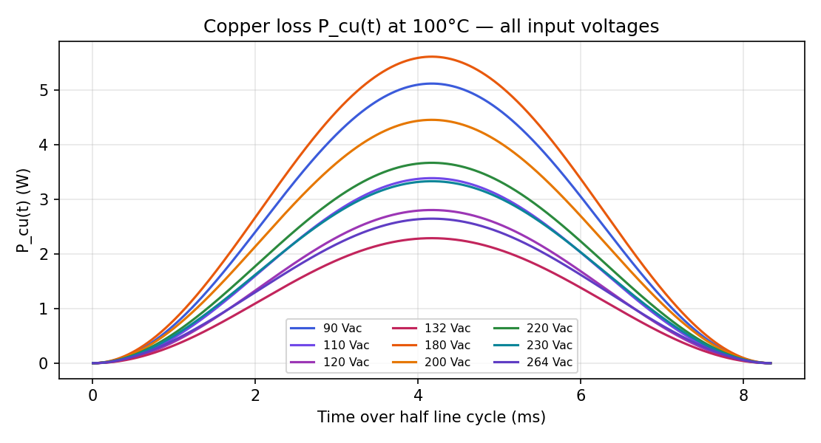
Figure 13.1 — P_cu(t) at 100 °C, all input voltages.
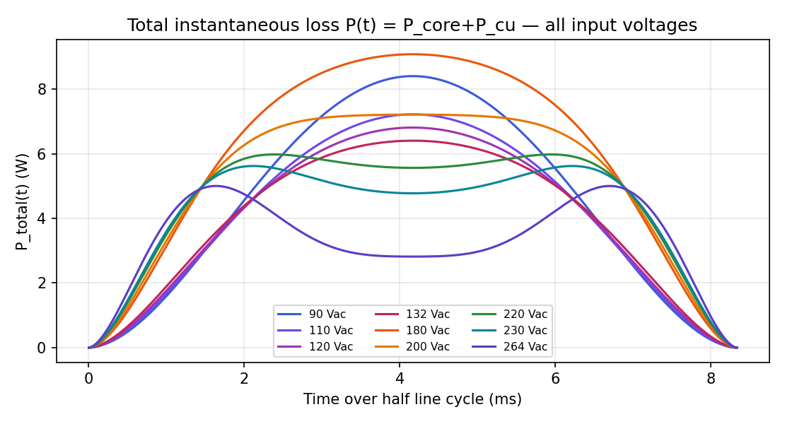
Figure 13.2 — Total instantaneous loss P(t), all input voltages.

Step 14) Thermal — Temperature Rise
ΔT[°C] = (P_total[mW] / SA[cm²])^0.833
SA = [π·OD_w·OH + (π/2)(OD_w²−hole²) + π·hole·OH]/100 = 102.2 cm² (OD_w 45.3, hole 8, OH = 2×17.89+6.6 mm)
V_in (Vac) | P_total max (W) | ΔT (°C)
90 | 4.56 | 23.7
110 | 4.15 | 21.9
120 | 4.05 | 21.4
132 | 3.98 | 21.1
180 | 5.88 | 29.3
200 | 5.17 | 26.3
220 | 4.54 | 23.6
230 | 4.22 | 22.2
264 | 3.31 | 18.1
Iterated steady state at Ta = 50 °C (180 Vac, max anchor): copper re-evaluated at the converged winding temperature gives P_total ≈ 5.69 W, ΔT ≈ 28.6 °C → winding ≈ 79 °C, leaving >120 °C margin to the 200 °C coating rating. The losses in Step 12 use a conservative fixed 100 °C winding.
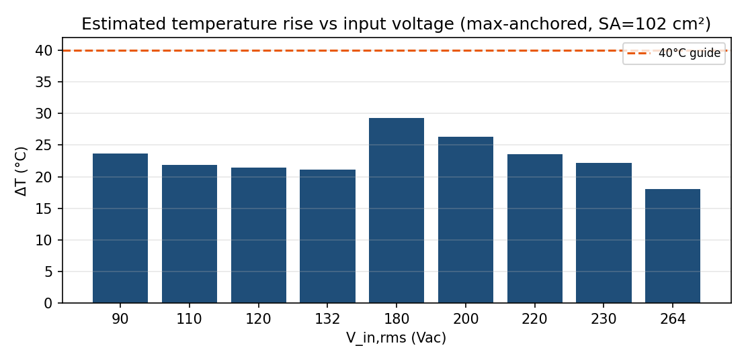
Figure 14.1 — Estimated temperature rise vs input voltage.

Step 15) Ripple Current and CCM/DCM Boundary
ΔI_pp(t) = V_in(t)·D(t) / (L(t)·f_sw) CCM if iφ,avg(t) > ΔI_pp(t)/2
V_in (Vac) | ΔI_pp max (A) | ΔI_pp @crest (A) | I_hf,rms (A) | CCM ratio @ZC
90 | 5.02 | 5.02 | 1.09 | 0.26
110 | 5.42 | 5.42 | 1.22 | 0.39
120 | 5.53 | 5.53 | 1.27 | 0.47
132 | 5.60 | 5.60 | 1.31 | 0.57
180 | 5.65 | 5.20 | 1.39 | 0.50
200 | 5.61 | 4.53 | 1.35 | 0.62
220 | 5.59 | 3.65 | 1.28 | 0.75
230 | 5.59 | 3.13 | 1.24 | 0.82
264 | 5.58 | 0.92 | 1.09 | 1.05
CCM ratio ≤ 0.51 everywhere at full load → CCM holds across the whole half-cycle, validating the core-loss waveform model. DCM appears near the zero-crossings only below ~50% load.
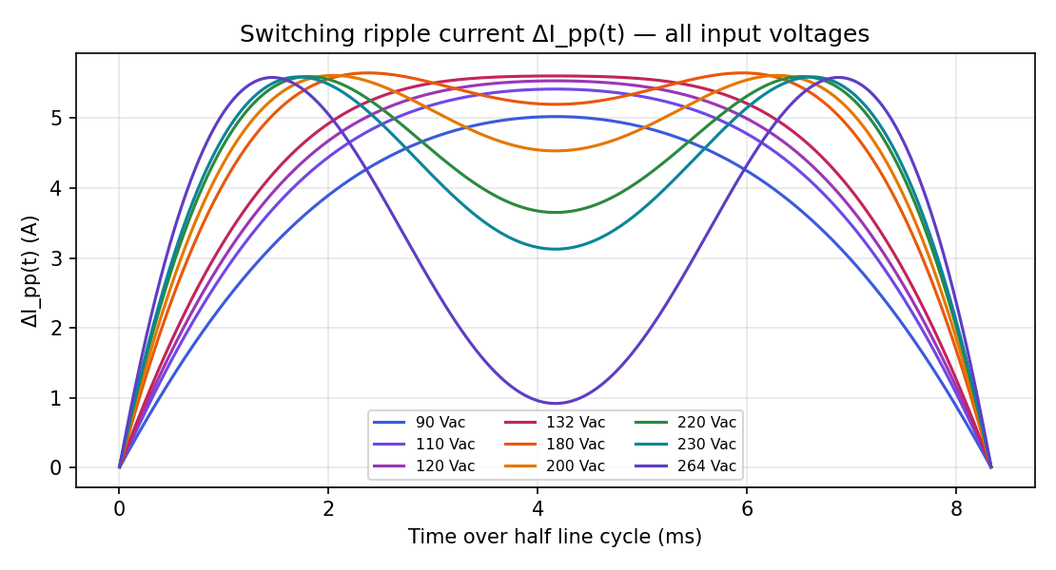
Figure 15.1 — ΔI_pp(t) over half line cycle, all input voltages.

Step 16) Saturation and Inductance Margin
Operating point | Current (A) | H (Oe) | L (µH)
Crest average (180 Vac) | 14.82 | 63.4 | 243.0
Instantaneous peak (avg + ½ ripple) | 17.41 | 74.5 | ≈239
80 % inductance point | 30.4 | 130 | ≈195
50 % inductance point | 47.9 | 205 | ≈125
Peak flux 0.43 T vs ≈1 T saturation; 50% inductance not reached until 2.8× the operating peak current. EDGE soft saturation degrades gracefully under surge.
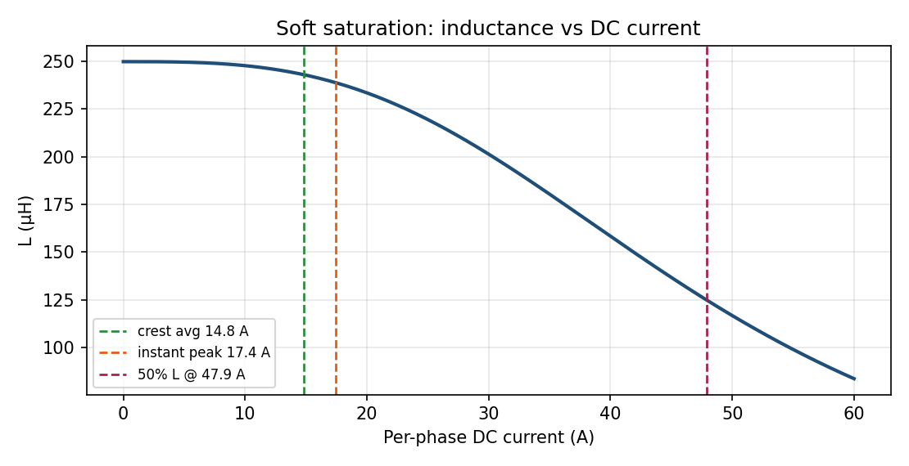
Figure 16.1 — L vs DC current with operating and margin points.

Step 17) Interleaving Ripple Cancellation (System Level)
K(D) = (1−2D)/(1−D) for D≤0.5 ; (2D−1)/D for D>0.5 (input ripple ÷ per-phase ripple, residual at 2·f_sw = 140 kHz)
Per-inductor flux and loss are NOT reduced by interleaving — every prior step analyzes one inductor at its full current. The benefit is input-side: best cancellation near D = 0.5 (~132 Vac crest).
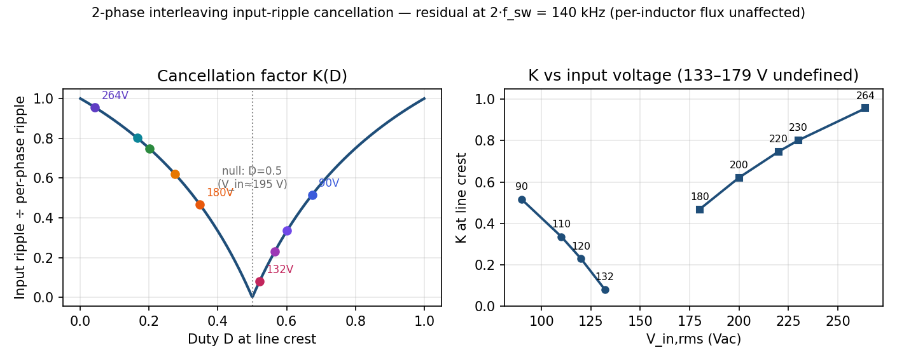
Figure 17.1 — 2-phase cancellation: K(D) with labeled crest points (left) and K vs input voltage per regime (right).

Step 18) Current Density and Window Utilization
Metric | Value
Current density J (worst RMS / 3.14 mm²) | 3.37 A/mm²
Bare Cu / insulated fill | 28.3 % / 70.4 %
Layers (geometric screening) | 4 (26/20/14/8)
Feed hole remaining | ≈ 3.46 mm

Step 19) Energy Storage and Core Utilization
Metric | Value
Stored energy ½·L·I_pk² | 37 mJ
Energy density | 1.27 mJ/cm³
Area product available (Wa·Ae) | 10.86 cm⁴
Area product required / utilization | ≈10.96 cm⁴ → ≈101 % (well-utilized)

Step 20) Converter-Level Roll-Up and Efficiency Impact
V_in (Vac) | P_in (W) | Per-inductor typ (W) | Per-inductor max (W) | 2-inductor total max (W) | % of input
90 | 1801 | 4.12 | 4.56 | 9.1 | 0.51 %
110 | 1783 | 3.61 | 4.15 | 8.3 | 0.47 %
120 | 1764 | 3.47 | 4.05 | 8.1 | 0.46 %
132 | 1747 | 3.36 | 3.98 | 8.0 | 0.46 %
180 | 3772 | 5.21 | 5.88 | 11.8 | 0.31 %
200 | 3736 | 4.53 | 5.17 | 10.3 | 0.28 %
220 | 3733 | 3.94 | 4.54 | 9.1 | 0.24 %
230 | 3722 | 3.65 | 4.22 | 8.4 | 0.23 %
264 | 3820 | 2.87 | 3.31 | 6.6 | 0.17 %

Step 21) Tolerance and Sensitivity
Variable | Range | Effect
Core AL | ±8 % | L 224–265 µH; ripple ∓8 %; core & copper loss unchanged (flux is volt-second set)
Winding temperature | 25 → 100 °C | P_cu +30 % (see Step 12 25 °C column)
Turns N | 31 / 32 / 33 | L ∝ N²; fewer N → higher B and core loss, lower copper
Core-loss anchor | typ → max | core loss +29 % (a = 67.4 → 86.7) — dominant open uncertainty

Step 22) Material Validity at the Operating Point
Property | At operating point | Valid
µ vs frequency | flat to ~3 MHz; f_sw = 70 kHz | ✓
µ vs DC bias | 97 % at 63 Oe (knee 130/205 Oe) | ✓
µ vs AC flux | ripple 0.06 T ≪ bias excursion | ✓
µ vs temperature | EDGE best-in-class alloy-powder stability at 80–100 °C | ✓
Loss model | reproduces datasheet 525 mW/cm³ anchor | ✓

Step 23) Validation and Measurement Plan
Verify | Method | Confirms
L vs I (Steps 5, 16) | LCR with DC-bias fixture to ≥18 A | turns, retention, saturation margin
Core loss (Step 11) | two-winding B-H loop, phase de-skewed | iGSE model & anchor coefficient
Total loss (Step 12) | calorimetry — ground truth | core + copper, mechanism-independent
ΔT (Step 14) | winding thermocouple + IR at full load | thermal envelope model
Ripple/CCM (Step 15) | current probe across line cycle | CCM assumption

Step 24) Summary
Item | Value
Core | EDGE 0059392A2 × 2 stack (60µ, AL 244 nH/T², Ae 306 mm², Ve 29.2 cm³)
Turns / wire | N = 32, dual TRW litz 0.1×200 (3.14 mm² Cu)
L₀ / L_full @ low line | 249.9 / 243.9 µH (target 235 µH ✓; AL−8 % gives ~224 µH)
Peak flux / saturation margin | 0.43 T / >2.3× to ≈1 T; 50 % L at 47.9 A (2.8× peak)
DCR @100 °C / window fill | 25.26 mΩ / 70.4 % insulated (4 layers, 3.46 mm feed hole)
Worst-case loss (180 Vac, 100 °C) | 5.21 W typ / 5.88 W max per inductor (instantaneous peak 9.1 W at crest)
Temperature rise | ≈29 °C → winding ≈79 °C @ 50 °C ambient (rating 200 °C)
CCM / interleaving | CCM across full half-cycle at full load; input ripple residual at 140 kHz
Open items | exact standard-EDGE 60µ loss coefficient (typ vs max band); winding-house confirmation of 4-layer / 3.5 mm feed-hole build; measured wound SA for thermal
Model: validated EDGE 60µ coefficients (catalog/datasheet), true iGSE triangular-ripple correction, time-domain cycle-averaged losses, converter currents per supplied Table A. All figures and tables generated from a single consistent engine, cross-checked against the interactive studio tool (V5.1).

